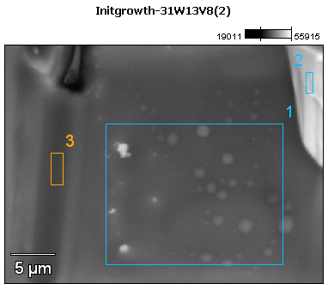

Image Name: Initgrowth-31W13V8(2)

Image Resolution: 512 by 384

Image Pixel Size: 0.07 µm

Acc. Voltage: 13.0 kV

Magnification: 3500

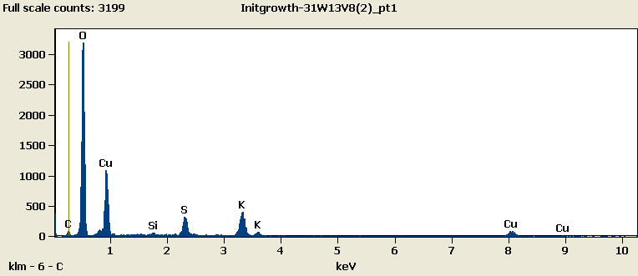

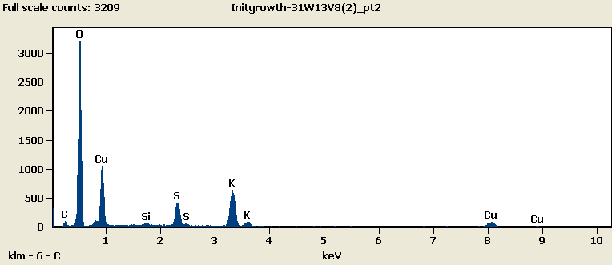

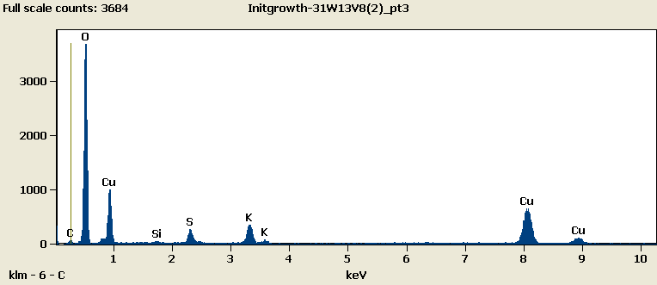

Weight %

|  |  |  |  |  |  |  |
| --- | --- | --- | --- | --- | --- | --- |
|  | ***C-K*** | ***O-K*** | ***Si-K*** | ***S-K*** | ***K-K*** | ***Cu-L*** |
| ***Initgrowth-31W13V8(2)_pt1*** | 1.82 | 49.65 | 0.38 | 5.07 | 9.83 | 33.25 |
| ***Initgrowth-31W13V8(2)_pt2*** | 2.34 | 48.46 | 0.37 | 6.36 | 13.36 | 29.10 |
| ***Initgrowth-31W13V8(2)_pt3*** | 2.59 | 53.57 | 0.41 | 3.95 | 8.07 | 31.40 |

Weight % Error (+/- 1 Sigma)

|  |  |  |  |  |  |  |
| --- | --- | --- | --- | --- | --- | --- |
|  | ***C-K*** | ***O-K*** | ***Si-K*** | ***S-K*** | ***K-K*** | ***Cu-L*** |
| ***Initgrowth-31W13V8(2)_pt1*** | ±0.35 | ±0.37 | ±0.05 | ±0.16 | ±0.26 | ±0.46 |
| ***Initgrowth-31W13V8(2)_pt2*** | ±0.33 | ±0.37 | ±0.05 | ±0.16 | ±0.26 | ±0.42 |
| ***Initgrowth-31W13V8(2)_pt3*** | ±0.20 | ±0.35 | ±0.05 | ±0.16 | ±0.26 | ±0.46 |

# Cations

|  |  |  |  |  |  |  |
| --- | --- | --- | --- | --- | --- | --- |
|  | ***C-K*** | ***O-K*** | ***Si-K*** | ***S-K*** | ***K-K*** | ***Cu-L*** |
| ***Initgrowth-31W13V8(2)_pt1*** | 0.00 | 0.00 | 0.00 | 0.00 | 0.00 | 0.00 |
| ***Initgrowth-31W13V8(2)_pt2*** | 0.00 | 0.00 | 0.00 | 0.00 | 0.00 | 0.00 |
| ***Initgrowth-31W13V8(2)_pt3*** | 0.00 | 0.00 | 0.00 | 0.00 | 0.00 | 0.00 |